Project Design Phase-II
Data Flow Diagram & User Stories

Date | 23 June 2026
Team ID
Project Name | An employee requests installation of licensed software through the Service Catalog
Maximum Marks | 4 Marks

Data Flow Diagram:
The Data Flow Diagram (DFD) illustrates how information flows through the Software Installation Request Automation system developed using ServiceNow.
- Employee (Requester):
The process begins when an employee accesses the ServiceNow Service Portal and submits a software installation request by providing details such as Software Name, Version Required, Business Justification, and Urgency.
- Service Catalog:
The submitted request is received by the Service Catalog, where the catalog item validates the input and creates a new service request.
- Workflow & Approval Process:
After the request is created, the Workflow Editor automatically initiates the approval process. Depending on the workflow configuration, the request is routed to the appropriate approver (such as a manager or software asset team) for review and approval.
- ServiceNow Database:
Once approved, the request details are stored in the ServiceNow database across the Request (REQ), Requested Item (RITM), and Catalog Task (SCTASK) tables. These tables maintain all request information and its current status.
- Catalog Task Creation:
The workflow automatically generates a catalog task and assigns it to the IT Software Support Team, enabling them to perform the required software installation.
- Notifications:
Throughout the request lifecycle, ServiceNow sends automated email notifications to employees, approvers, and IT support staff regarding request submission, approval decisions, task assignments, and completion status.
- Request Fulfillment:
The IT Software Support Team completes the installation task and updates the task status. Once all tasks are completed successfully, the workflow automatically closes the request and updates the employee with the final status.
This data flow ensures that software installation requests are processed efficiently through automated workflows, approvals, task assignments, notifications, and centralized data management, reducing manual effort and improving the overall user experience.

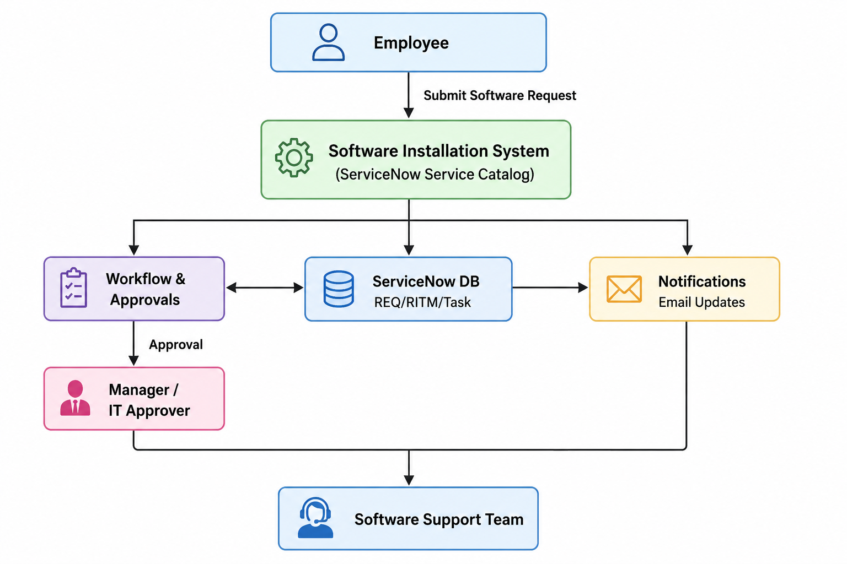

User Stories
User Type | Functional Requirement (Epic) | User Story Number | User Story / Task | Acceptance Criteria | Priority | Release
Employee (Requester) | Software Request Submission | USN-1 | As an employee, I can submit a software installation request through the Service Catalog. | Request is successfully created with a REQ number. | High | Sprint-1
Employee (Requester) | Software Request Submission | USN-2 | As an employee, I can enter Software Name, Version, Business Justification, and Urgency. | Request details are saved successfully. | High | Sprint-1
Employee (Requester) | Request Validation | USN-3 | As an employee, I must complete all mandatory fields before submitting the request. | The system prevents incomplete submissions. | High | Sprint-1
Employee (Requester) | Request Tracking | USN-4 | As an employee, I can track the status of my software request. | Current request status is displayed. | High | Sprint-2
Manager / Approver | Workflow & Approval | USN-5 | As a manager, I can approve or reject software requests. | Approval decision updates the workflow. | High | Sprint-2
IT Support Engineer | Catalog Task Management | USN-6 | As an IT Support Engineer, I receive catalog tasks for software installation. | Catalog task is automatically created and assigned. | High | Sprint-2
IT Support Engineer | Request Fulfilment | USN-7 | As an IT Support Engineer, I can update the installation task status. | Task status changes are reflected in the request. | Medium | Sprint-3
Employee (Requester) | Notifications | USN-8 | As an employee, I receive notifications when my request is approved and completed. | Email notifications are successfully delivered. | Medium | Sprint-3
ServiceNow Administrator | Workflow Administration | USN-9 | As an administrator, I can configure workflows, catalog items, and approvals. | Configuration changes are applied successfully. | High | Sprint-1
ServiceNow Administrator | Update Set Management | USN-10 | As an administrator, I can migrate configurations using Update Sets. | Update Set is successfully previewed and committed. | Medium | Sprint-3

